#9

**The Robot Arm**

In the process of selecting a robot arm kits that can perform well within our budget. We got The Lynxmotion AL5D robot arm which is a 5 degree of freedom robotic arm kit. It consists of four servos, one at the base for 180 degrees from left to right rotation, one above the base for forward and backwards movement, one at the shoulder for up and down rotation, one control the opening and closing of the gripper, and one rotate the wrist. The arm is tested to hold up to 10oz at full reach.

The parts of the arm were assembled together within a week. The reason for that was, some parts were compatible and needed drilling to put together. And a sample code was written to test each servo movement, and record original position values of the servos.

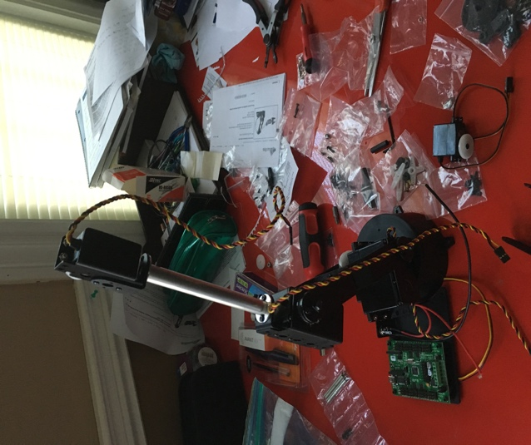

**The Servo Controller**

A SSC­32U servo controller that can control up to 32 servos, which are laid out as two separate sections of 16 servos, each grouped together in sets of four. Pins 0 to 15 corresponds to VS1. second set of 16 pins. Pins 16 to 31 correspond to VS2. The servo controller can power and control 32 servos. Each servo comes 3­pin cable and connector: Red = 4.8V to 6V (VS)  
Black / brown = GND and orange = Signal Pulse Width Modulation” (PWM)



**The Mobil Platform**

We came up with a mobile platform to move the robot arm to desired destination. First we looked for four identical and affordable servos with enough torque capable of moving the arm with the platform. The arm weight roughly about 5 pounds. Each servo has 2.8 pounds’ torque capability under 6V. With 4 identical servos the platform is capable of moving up to 11 pounds. The servos used in for the platform are Continuous Rotation Servo Free Tech (FS503R)

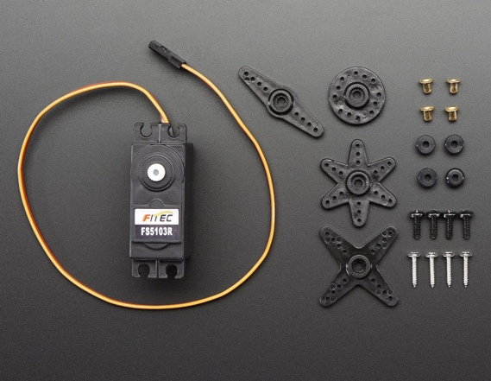

Details:

* Continuous Rotation Servo Free Tech (FS503R)
* Operating Voltage: 4.8V~6V (5V works best)
* Average Speed: ~0.18sec/60°
* Stall Torque (4.8V): 3kg.cm/41.74oz.in
* Stall Torque (6V): 3.2kg.com.in
* Required Pulse: 500us-2500us
* Connector Wire Length: 30cm / 11.8"
* Dimensions: 37mm x 54mm x 20mm / 1.5" x 2.1" x 0.8"
* Weight (no horns): 40g
* Spline Count: 25

The platform parts

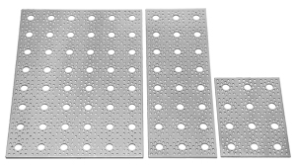

**9” x 12” #585006** (0.70 lbs)

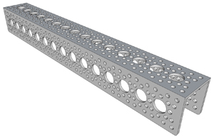

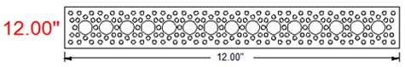

**Weight:** 0.28 lbs (4.48 Oz)

four wheels (28109)

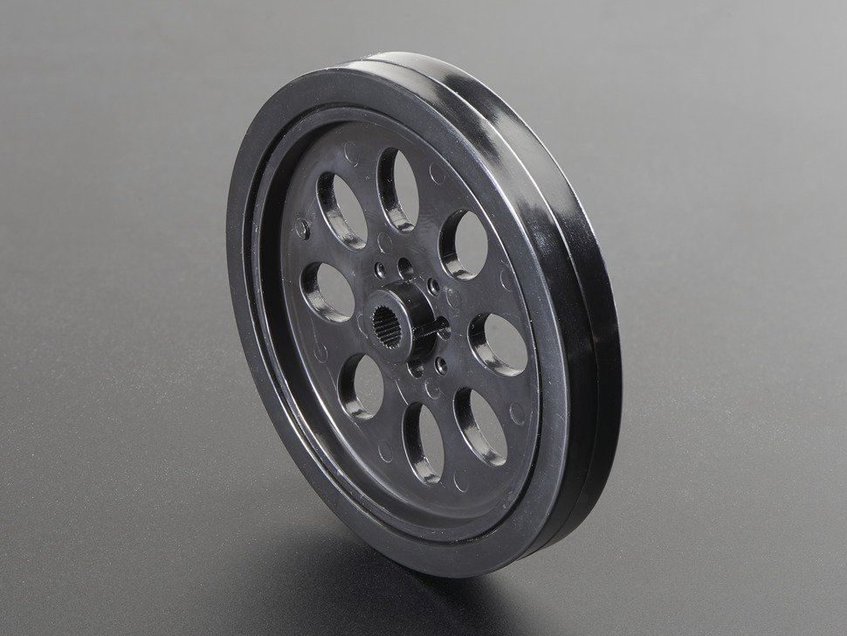

2.62” (66.5mm)

All four servos of the platform are also controlled by A SSC­32U servo controller.

To be able to easily identify to platform servos from the arm servos we use the section of VS2

Front right and back right tires are connected to port 16 and 17 respectively.

Front left and back left tires are connected to port 31 and 30 respectively.

**Wireless Camera**

A wireless camera used to provide clear vision of the the robot arm motion. The camera transmits video over a 5.8GHz frequency to a receiver. The receiver can be connected to a monitor and display video from the camera. Field view of 120 degrees, transmitting power is 200mW. We chose 5.8GHz frequency to avoid interference with the wireless Xbee which operates at 2.4 GHz frequency.

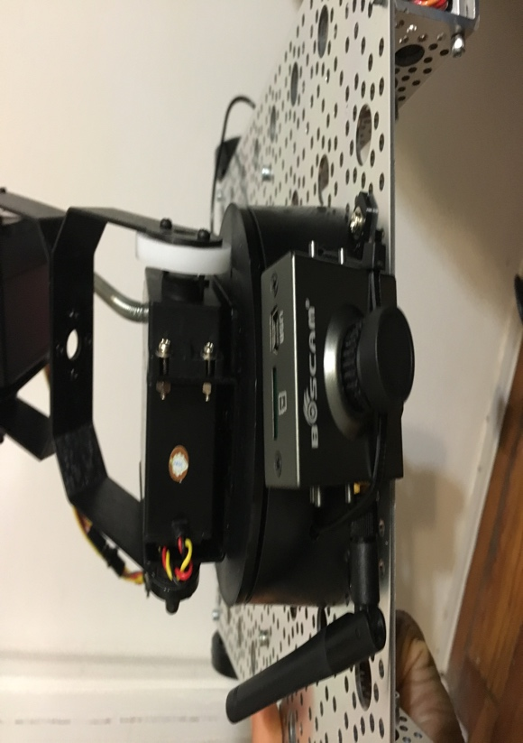

Since the receiver only comes with an AV output we bought a small video converter that converts AV input to VGA output. The reason for that it will allow us to use any computer monitor.

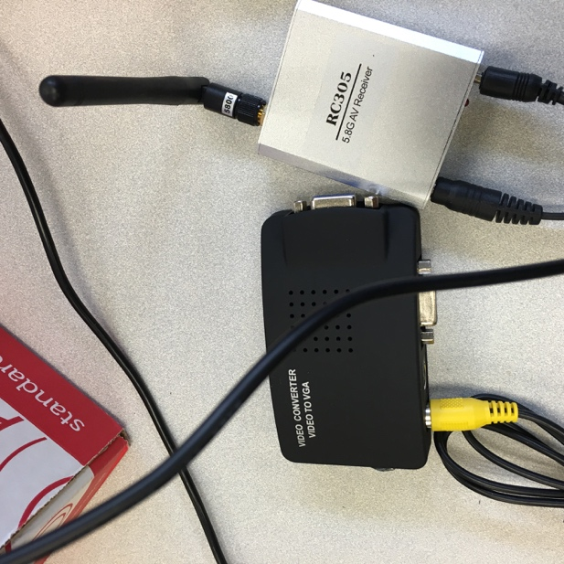

**Power Supply**

A 12V DC Output Lithium Ion Battery Pack with Charger, Multi-led indicator Black (3000mAh

rechargeable used to power the wireless camera.

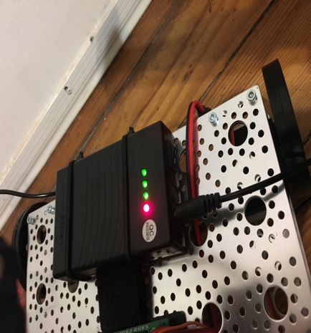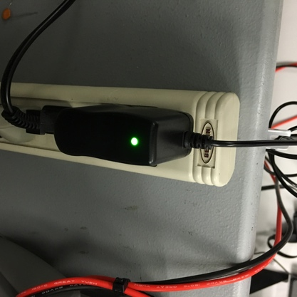

Since the wireless camera receiver is stationary and also require 12V DC to operate we use the same battery charger to power the it. To help easy access to plug and unplug the the batteries when they need to be charged we changed the wires with 10 inch(30cm) 2.1 x 5.5mm DC Power Pigtail Female + 2.1 x 5.5mm DC Power Pigtail MALE

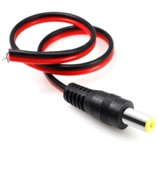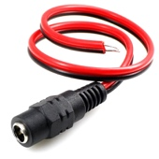

A 6 Volts DC 2000mAh NiMH RX Battery Packs rechargeable battery is used to to power the servos controller to mobilize the robot for up to 3hours on a single charge, and only need about 30min to be fully charged.

